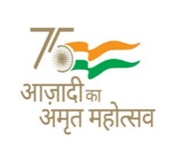



**CBSE Affiliation No. 2400008**

**School No.19234**

**केन्द्रीय विद्यालयहासीमारा**

Kendriya Vidyalaya Hasimara

**(शिक्षा मंत्रालय,** भारत सरकार**)**

(MinistryofEducation, Govt. of India)

**एयर फोर्स स्टेशन हासीमारा/**Air Force Station Hasimara

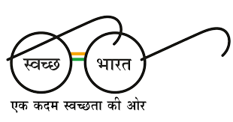**अलीपुरद्वार/Alipurduar** –735215पश्चिम बंगाल/ West Bengal)

•**ई-मेल/**E-Mail-principalhasimara@gmail.com

दूरभाष/Phone: 03566-255001वेवसाइट/Website:https://hasimara.kvs.ac.in

**ENLISTMENT NOTICE**

Proposals are invited from eligible Career and Guidance service for Psychometric Test & Career Counselling session for Students of KV, Hasimara.

1. Psychometric Test
2. Career Counselling
3. Submit self-attested copies of eligibility certificate, GST Certificate/Registration, PAN No. etc. by e-mail.
4. For incomplete enclosures the proposal may be rejected without any information.
5. Last date of submission of application is 22-01-2024.

By Order

Principal